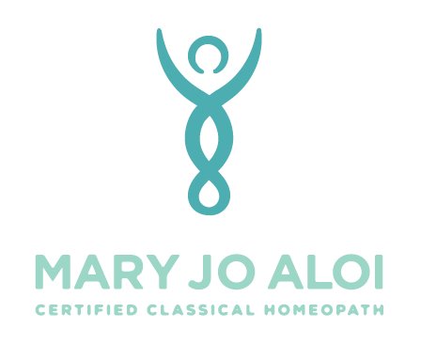
(408) 823-0560
My signature below indicates that I understand and accept the following:
Mary Jo Aloi is not a medical doctor, has not presented herself as such, and is not licensed in the diagnosis or treatment of disease. Mary Jo Aloi is not a licensed physician.

Homeopathy is an alternative/complementary approach to the healing arts services that are licensed by the state of California. Homeopathic consulting services provided by Mary Jo Aloi are not licensed by the state of California.

Homeopathy is a two hundred-year-old system of healing. Homeopathic remedies do not treat specific conditions but stimulate the body’s defenses to heal. The homeopath views a person’s health as a condition of the entire individual rather than in terms of the presence or absence of isolated symptoms. Remedies are selected which best correspond to the person’s total state. Homeopathy is a system for the overall enhancement of my health.
The F.D.A. regulates homeopathic remedies and classifies them as over-the-counter medications. As no prescription is necessary, I am choosing to administer homeopathic remedies to myself.
While I am consulting her for homeopathic advice, I agree to maintain my relationship with my regular health care providers. I realize and agree that I alone am responsible for my health and well being.
Mary Jo Aloi holds diplomas from Florida Atlantic University (B.S. Chemistry, 1989), The School of Homeopathy, Devon (3 year certificate program, 2007) and the Dynamis School for Advanced Homeopathic Studies (3 year certificate program, 2006). She has also done additional clinical training through the Caduceus Institute of Classical Homeopathy. She is certified as a Certified Classical Homeopath (CCH) by the Council for Homeopathic Certification.
________________________________________ _____________
Signature Date

