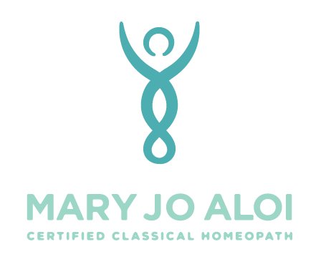
14127 Capri Dr, Suite 5A, Los Gatos, CA 95032
1595 38th Ave, Capitola, CA 95010
health@maryjoaloi.com
(408) 823-0560

Permission to Record Case Information

Recording details of consultations allows me to review our conversation for specific nuances that can be helpful in teasing apart casework. It is often not needed or used, however having it can be invaluable at times. I appreciate permission from you to do so, and I respect your wishes entirely if you do not wish to be recorded. Please sign this form and return only if you agree to be recorded.

I, ____________________________ , give Mary Jo Aloi my permission to record the details of my homeopathic consultation.

This information will be held in confidentiality in the same way written notes are treated and used expressly for the purposes of understanding the case and selecting the most indicated remedy.

____________________________________ ___________________
Signature Date

____________________________________
Printed Name

